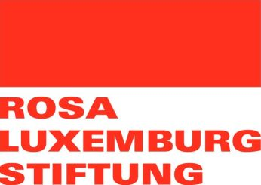
Letter of Intent – Funding of projects by RLS London during the year 2020
About your organization
Name of the organisation, address/ website, type of registration:

How is your organization financed and what other funds are you applying for in the near future?
What kind of activities has your organisation implemented in the past?

What problems in society does your organisation aim to address?
About your project
Project title:

What are the objectives of the project and who are the beneficiaries?

Which definite activities are you planning in 2020 with the support of RLS London?

Please describe how your project will contribute to political, social and cultural changes:

Please describe how your project will contribute to the four objectives of RLS London:

Expected funding (in EUR):

Please note the following important information:
- The Letter of Intent should be written in English, have a maximum length of 3 pages and all above questions should be answered.
- The Letter of Intent should be sent to deborah.hermanns@rosalux.org by 31st of October 2019, 23:59 CET , latest. We will not consider Letters of Intent which are sent after this date.
- Selected organisations will be contacted by RLS London until 14th of November 2019.
- The acceptance of the Letter of Intent does not guarantee that the project will be funded.
- Selected organisations will have to send a full project application by 2nd of December 2019, latest. The full application will have to be written on the basis of the RLS London Guidelines that will be provided to the selected organisations.
- On the basis of the full application a legally binding project agreement will be concluded between RLS London and the partner organisation by the end of 2019.

